**Afectivitatea. Forme ale vieții afective**

**-fișă de lucru-**

**Selectează 5 emoții pe care le-ai simţit recent şi conturează rolul acestora în momentul respectiv:**

|  |  |
| --- | --- |
| **Emoţie** | **Rolul** |
|  |  |
|  |  |
|  |  |
|  |  |
|  |  |

**Emisfera stângă a creierului este asociată emoțiilor pozitive, iar cea dreaptă- stărilor negative, depresive. Ce stări afective credeți că ar genera lezarea emisferei stângi. Dar a celei drepte?**

___________________________________________________________________________________________________________________________________________________________________________________________________________________________________________________________________________________________________________________________________________________________________________________________________________

**Alegeți două hobby-uri ale voastre. Sunt ele pasiuni? De ce?**

___________________________________________________________________________________________________________________________________________________________________________________________________________________________________________________________________________________________________________________________________________________________________________________________________________

**Robert Plutchik, Cele 8 emoții de bază și derivatele lor**

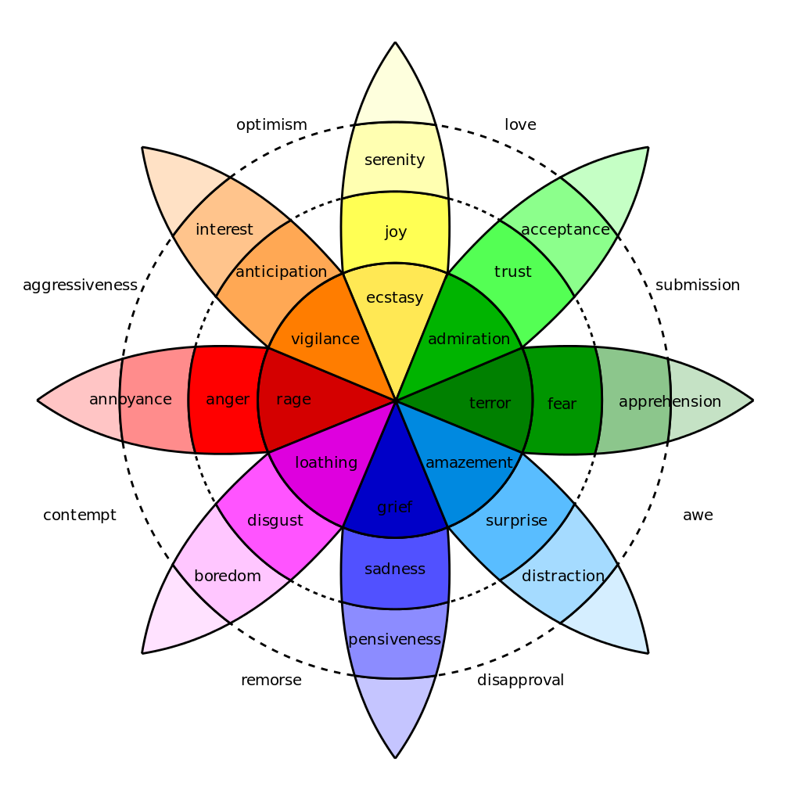

**Optimism**

**Agresiune**

**Dispreț**

**Remușcare**

**Dezamăgire**

**Iubire**

**Supunere**

**Respect**